Lielo objektu redaktori

TwistedBrush Open Studio 16.02 (bezmaksas)

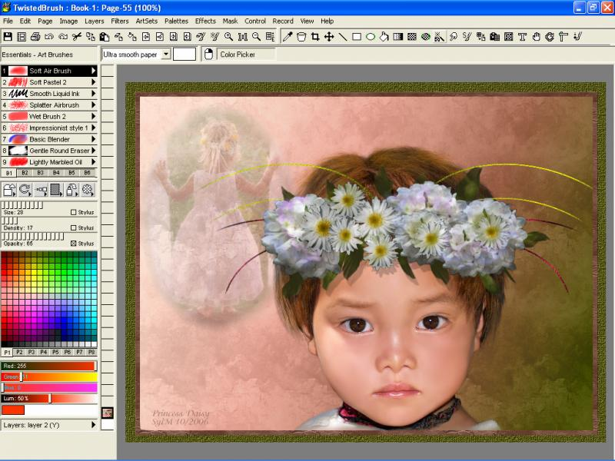
Digital paint software and photo editor with natural art tools. TwistedBrush Open Studio has one of the most versatile and powerful brush engines in existence, yet it as designed from day one to be easy to use. A handful of very fine brushes along with all the features that artists love to use: layers, realistic media, tracing, masks, particles, filters, drawing aids, reference images and tablet support

OraLobEditor 2.2

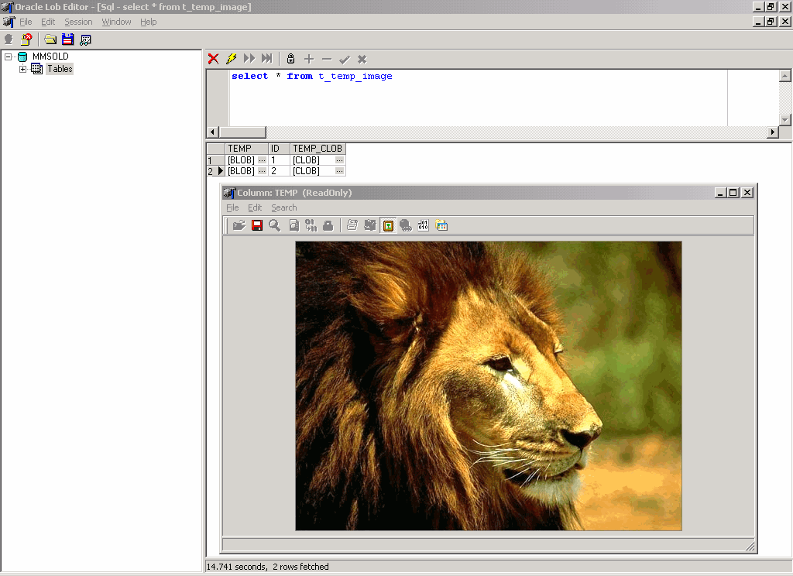
OraLobEditor is a Oracle LOB(CLOB,BLOB) field edit tool. The main features are:
1. View/Edit Oracle LOB ( BLOB, CLOB) data(plain text,RTF,image,hex,html,xml...).
2. Common image formats support(JPEG, GIF, BMP, PNG, TIFF...) .
3 Editing Oracle LOB(BLOB, CLOB) data in hexadecimal mode .
4 View Oracle LOB (BLOB, CLOB) data (image, pdf, word, excel, mp3 ...) with external tool.
5 Load LOB data from file, Save LOB data to file.
6 Import/Export LOB data.
Product homepage: http://www.withdata.com

DBBlobEditor 3.2 Withdata Software

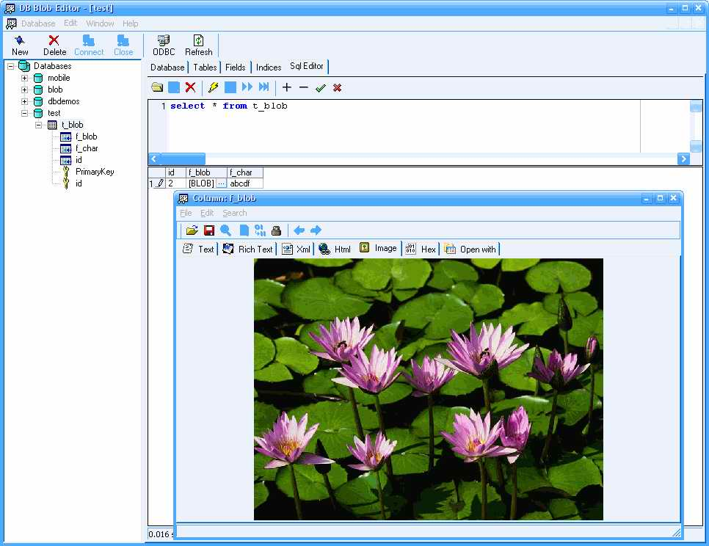
DB Blob Editor is a database blob field edit tool.
1. View/Edit BLOB Field(plain text, RTF, image, hex, html, xml...).
2. Connect to any datasource accesible via ADO using OLE DB Provider or ODBC (Oracle, Sql Server, Mysql, Access...).
3. Common image formats support (JPEG, GIF, BMP, PNG,TIFF...) .
4. Editing BLOB Field in hexadecimal mode .
5. View, edit, insert, and delete data in tables.

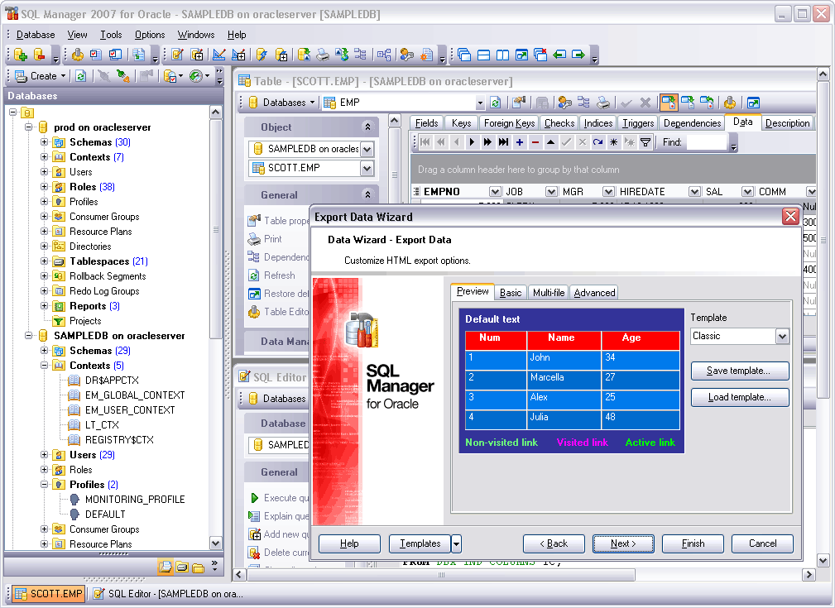
EMS SQL Manager 2007 for Oracle 1.1 EMS Database Management Solutions, Inc

EMS SQL Manager for Oracle is a high performance tool for Oracle Database Server administration and development. It offers plenty of powerful tools for experienced users such as Visual Database Designer, Visual Query Builder, and powerful BLOB editor to satisfy all their needs. SQL Manager for Oracle has a state-of-the-art graphical user interface with a well-described wizard system, so clear in use that even a newbie will not be confused with it.

